**INNOVATION**

**Flood Prediction Using LSTM**

* Short-term flood prediction involves prediction of a flooding event in real time

mostly anywhere between few minutes and hours preceding the flood .

* In contrast to long-term flood prediction, which is mostly used for policy analysis purposes, the aim of short-term flood prediction is to reduce damage and harm caused by a flood disaster.
* Short-term flood prediction systems with lead time are considered important research challenges, particularly in highly populated areas for timely warnings

to residences.

* Despite several improvements in statistical weather prediction models, artificial intelligence and machine learning methods, short-term flood prediction remains a challenging task.
* LSTM is utilized for short-term prediction of flood water levels. LSTM is mainly applied to input-output modelling of nonlinear dynamic systems such as time-series prediction. By observing a multivariate time series of rainfall and water level, the model outputs forecast of the water level ahead of time. The input to the model is ten time steps sequence of water level and rainfall data (i.e. ten hours) and the output is a forecast of the water level in ten hours. shows the pattern of LSTM prediction used in the forecasting of water levels. The input *x t* represents vector of rainfall and water level values and the output *y t* represents water level values at time *t*.

**Flood Forecasting Using ANN**

* Forecasting future data points using past time series data is of great interest for many applications that require time series analysis. Flood prediction is one of such type of applications as flood events can be modelled as non linear time series events. ANN have shown good results in working upon the non-linear times series data obtained from the sensors for prediction purpose.
* Nonlinear Autoregressive network with inputs (NARX)network is one of the ANNs that has been widely used in the prediction of floods and rainfall. NARX is a dynamic recurrent network with feed forward connections having multiple layers of network. NARX is mainly applied to input-output modelling of nonlinear dynamic systems such as time-series prediction . shows structure of a NARX neural network.

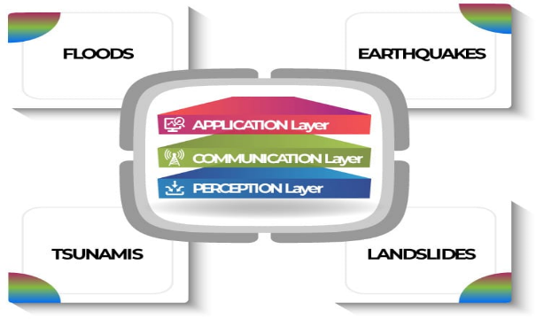

**IoT Flood EARLY WARNING Systems**

* IoT systems produce data that is immediately accessible for real-time warning applications.
* Prediction methods in EW IoT systems can rely on hydro-geological models or statistical and Machine Learning models that collect data in real time from WSNs, send them to a remote server for processing and then display results or generate alarms. illustrates a generic implementation of a flood Early Warning system based on the IoT which makes use of different types of sensors.
* 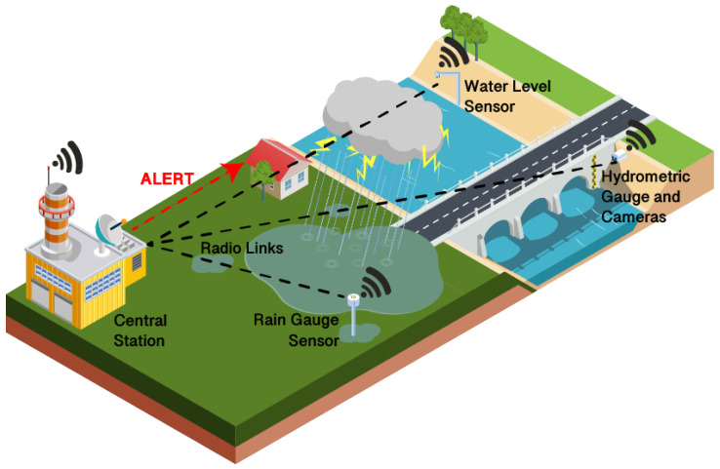 Important system requirements that were highlighted by the reviewed literature are:
* (i)coverage in remote areas and difficult terrains, which might require to discard certain IoT solutions as they might not be suitable for said environments;
* (ii) energy consumption, especially under certain environmental or weather conditions (such as “dark modes” of operation when using a photo-voltaic energy supply) or when certain measurement requirements are to be met; and
* (iii) fault tolerance and the ability of the sensor network to keep working even if some nodes fail, because of low battery or harsh weather conditions.